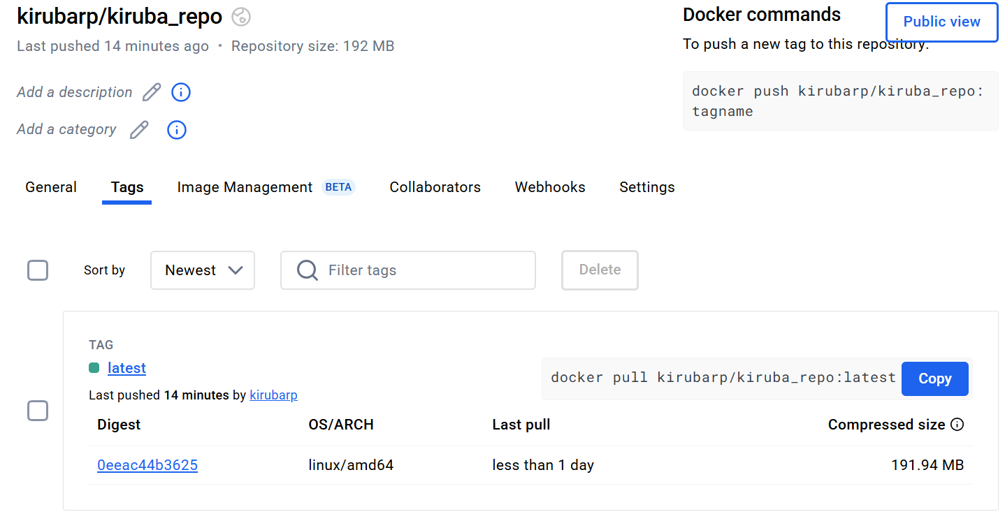

pipeline { agent any

tools {

jdk 'jdk21' nodejs 'node20'

}

stages {

stage('Clean Workspace') {

steps {

script {

echo "Cleaning workspace..."

deleteDir() // Deletes everything in the Jenkins workspace before starting

}

}

}

stage('Git Checkout') {

steps { script {

echo "Checking out the latest code from GitHub..." git branch: 'main',

credentialsId: 'github_seccred',

url: 'https://github.com/Kiruba-Prakasan/Docker_task_Kiruba.git['](https://github.com/Mithra07-Sriram/devops_training.git)

}

}

}

stage('Install Node') { steps {

script {

echo "Checking for package.json and installing dependencies..." sh '''

if [ -f package.json ]; then

echo "package.json found. Running npm install..." npm install else

echo "ERROR: package.json is missing. Skipping npm install." exit 1 fi '''

}

}

}

stage('Docker Build & Push') {

steps { script {

echo "Building and pushing Docker image..."

withDockerRegistry(credentialsId: 'docker', toolName: 'docker') { def imageName = "kirubarp/kiruba_repo"

def tag = "latest"

sh "docker build -t ${imageName} ."

sh "docker tag ${imageName} ${imageName}:${tag}" sh "docker push ${imageName}:${tag}"

}

}

}

}

stage('Deploy Docker Container') {

steps { script {

echo "Stopping and removing any existing containers..." sh "docker stop devops_container || true" sh "docker rm devops_container || true"

echo "Deploying new Docker container..." sh """

docker run -d --name devops_container -p 3001:3000 \

kirubarp/kiruba_repo:latest

"""

}

}

}

}

}

